Specular Reflection

📘 Definition
# Source: AI Source: Provided by: [Data Path: Persons Table -> ID Column: 1, Name_En Column: Motasem Essam] -> From: [ChatGPT] on [5/2/2026]
Specular reflection is a type of reflection where light bounces off a smooth surface in one clear direction, creating a sharp, mirror-like reflection.
It happens when the surface is very smooth or polished, so the light rays reflect in an organized way.

🪞 How specular reflection works
# Source: AI Source: Provided by: [Data Path: Persons Table -> ID Column: 1, Name_En Column: Motasem Essam] -> From: [ChatGPT] on [5/2/2026]
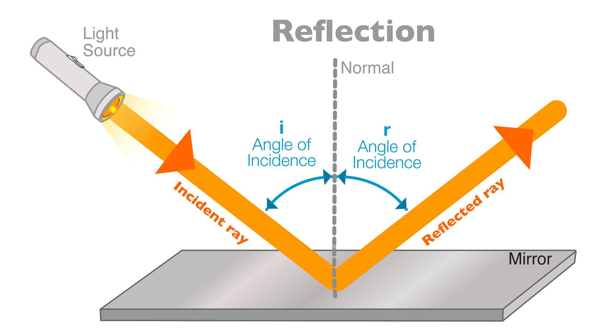
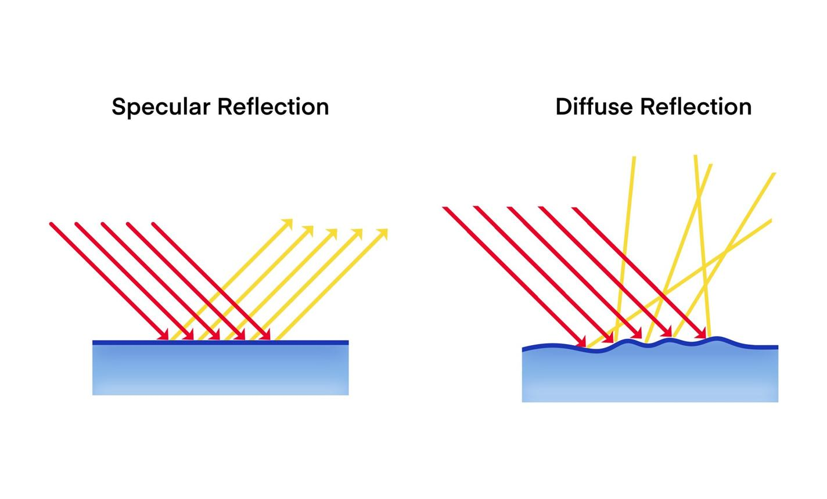
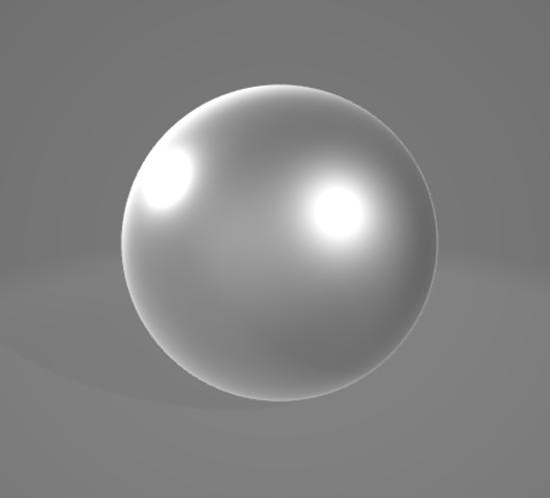
- Light hits a smooth surface
- Rays bounce off in a single direction
- The reflection is clear and sharp

🧠 Simple example
# Source: AI Source: Provided by: [Data Path: Persons Table -> ID Column: 1, Name_En Column: Motasem Essam] -> From: [ChatGPT] on [5/2/2026]
Think of:
- 🪞 A mirror showing your face clearly
- 💧 A calm lake reflecting mountains
- 🪙 A polished metal surface shining brightly

🎮 In computer graphics
# Source: AI Source: Provided by: [Data Path: Persons Table -> ID Column: 1, Name_En Column: Motasem Essam] -> From: [ChatGPT] on [5/2/2026]
Specular reflection is used to:
- Create shiny materials (metal, glass, water)
- Add highlights on objects
- Improve realism in lighting and rendering

⚙️ Key features
# Source: AI Source: Provided by: [Data Path: Persons Table -> ID Column: 1, Name_En Column: Motasem Essam] -> From: [ChatGPT] on [5/2/2026]
- ✨ Produces sharp, clear reflections
- 🪞 Happens on smooth surfaces
- 🎯 Directional (follows reflection angle rule)
- 💡 Creates bright highlights (glare spots)

🚀 In short:
# Source: AI Source: Provided by: [Data Path: Persons Table -> ID Column: 1, Name_En Column: Motasem Essam] -> From: [ChatGPT] on [5/2/2026]
Specular Reflection = a clear, mirror-like reflection of light from smooth surfaces.

